**Project Ideas**

# **Levels:**

## Test Map (Firing Range)

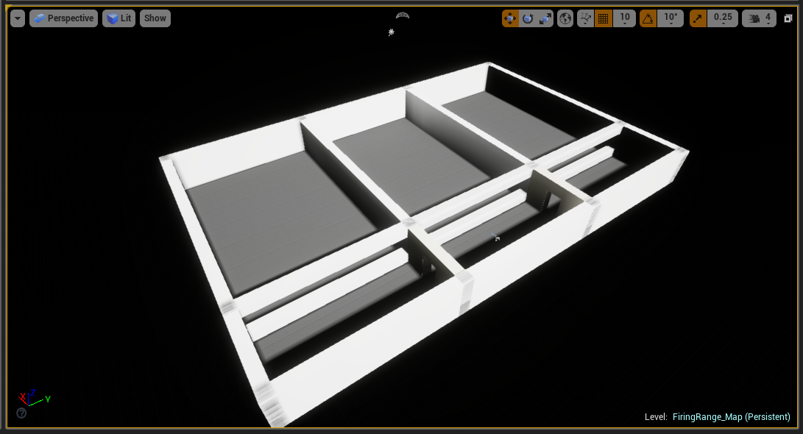

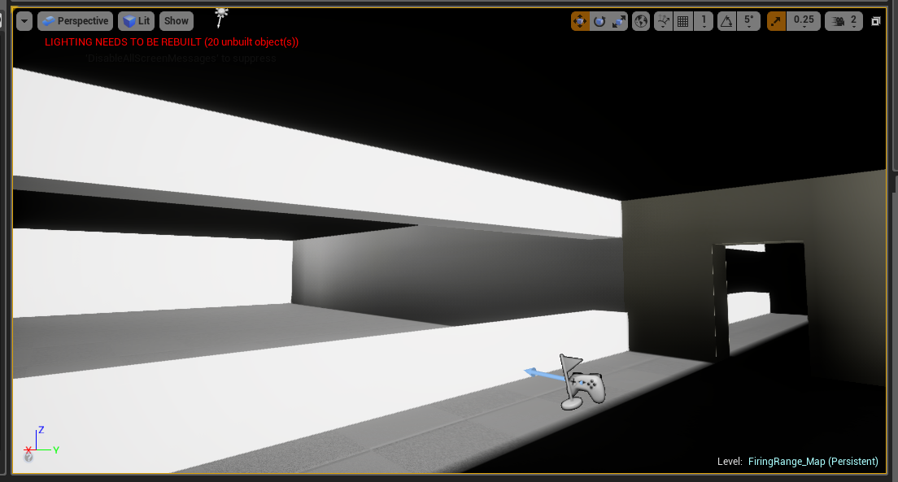

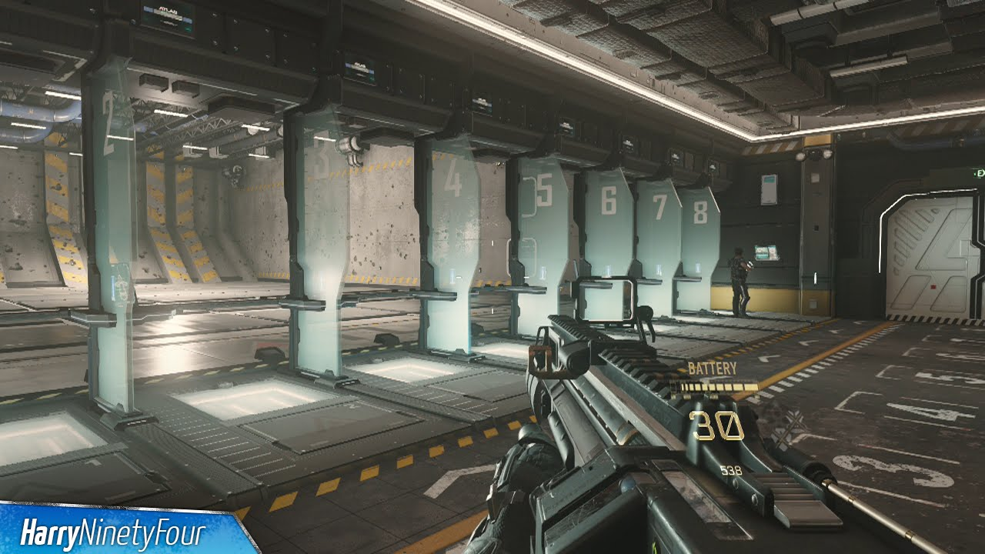

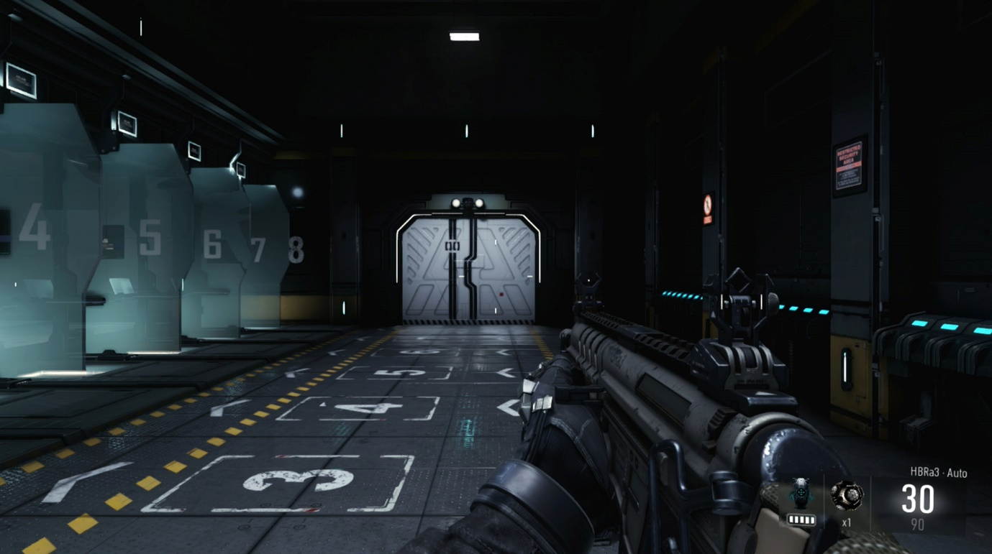

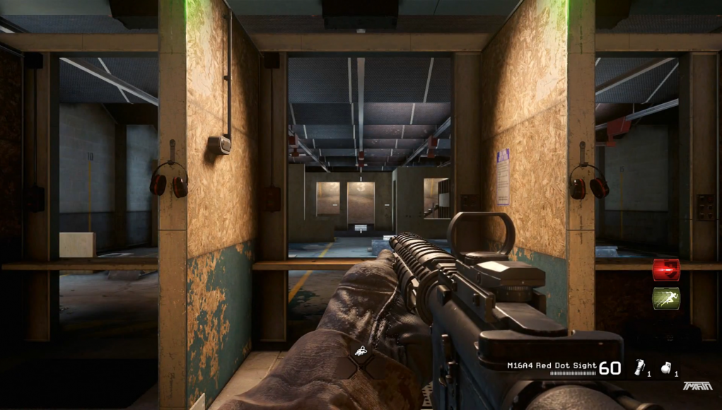

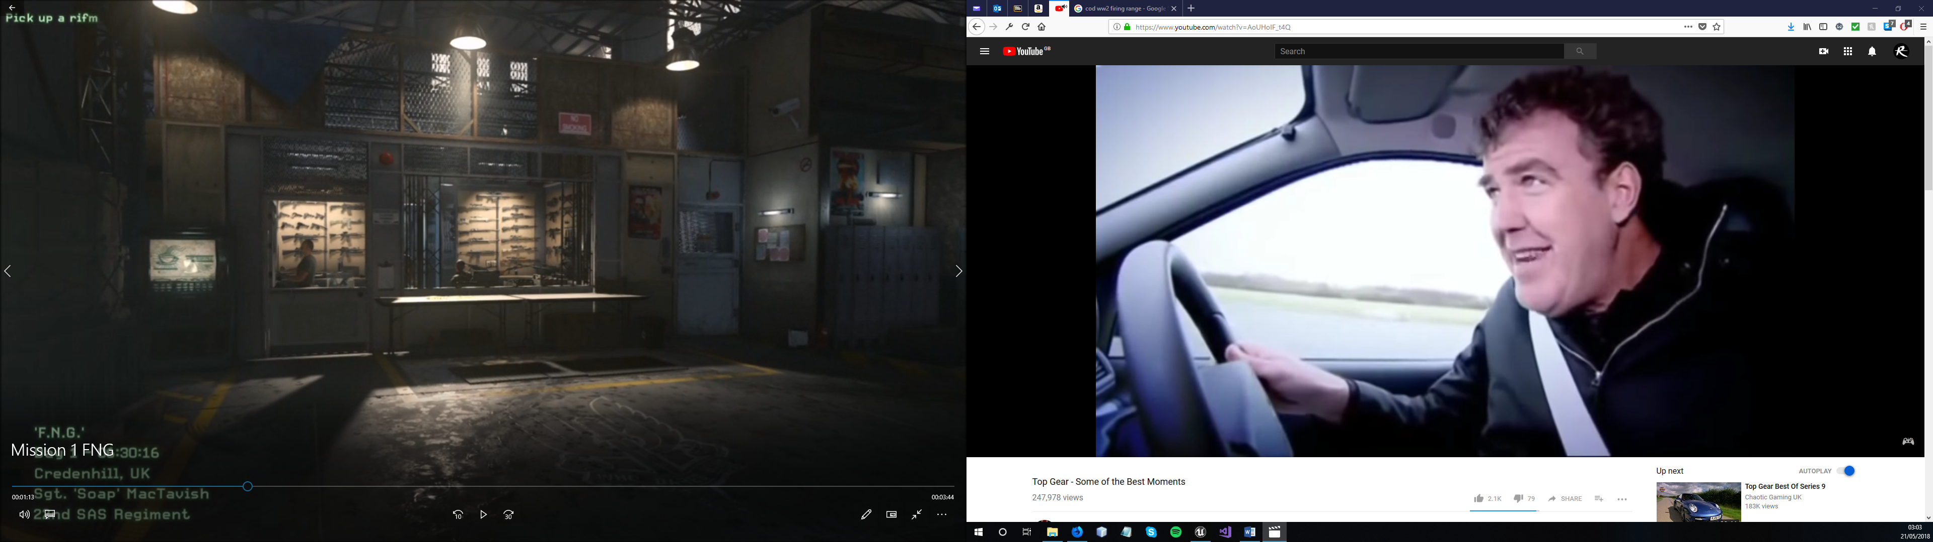

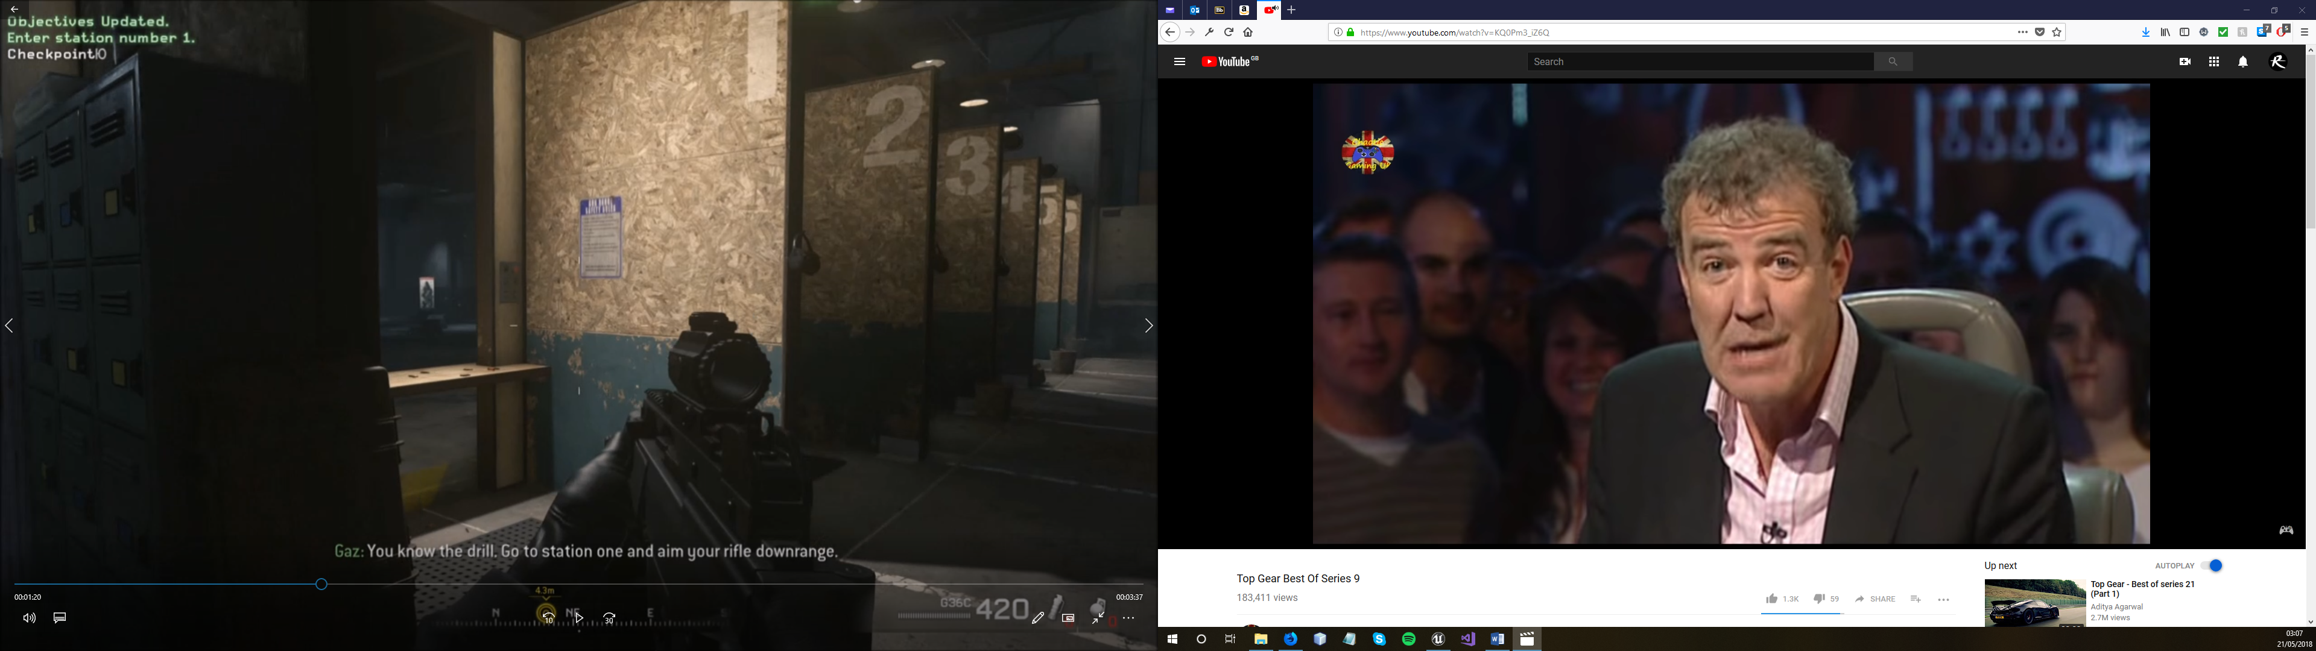

## Level 1, 2, 3?

## One single level?

# **Gameplay:**

* Shooter?
* Third-person?
* Top-down?
* Friendly and enemy AI?
* Operation Flashpoint: Rising Dragon
* Issue commands to AI?

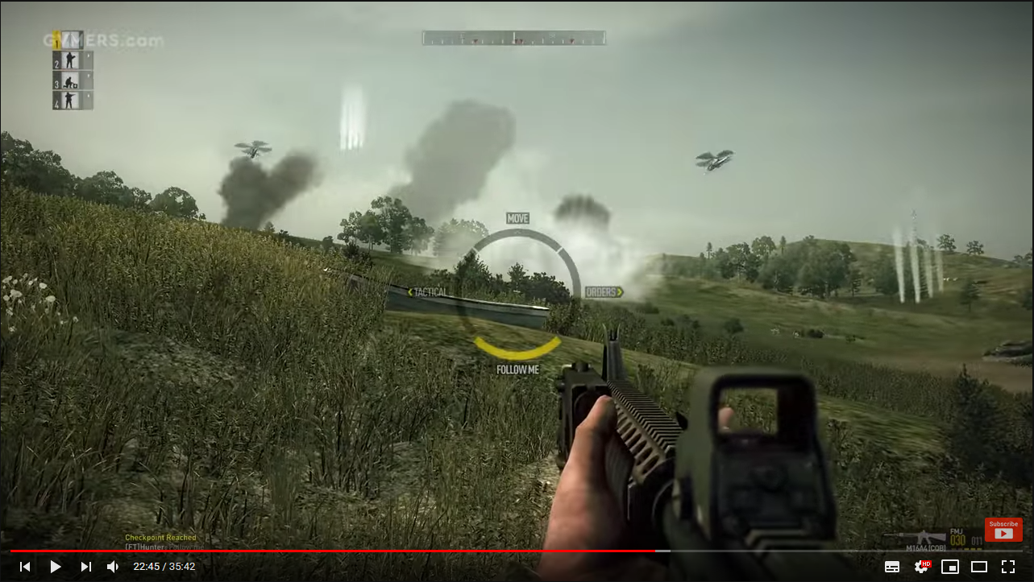

* Conflict Desert Storm II (<https://www.youtube.com/watch?v=PO4YBr4dto0>)
* Camera view and position
* HUD
* Ability to transfer inventory items and health others
* Commands such as: “fire at will”, “on me”, “hold position”

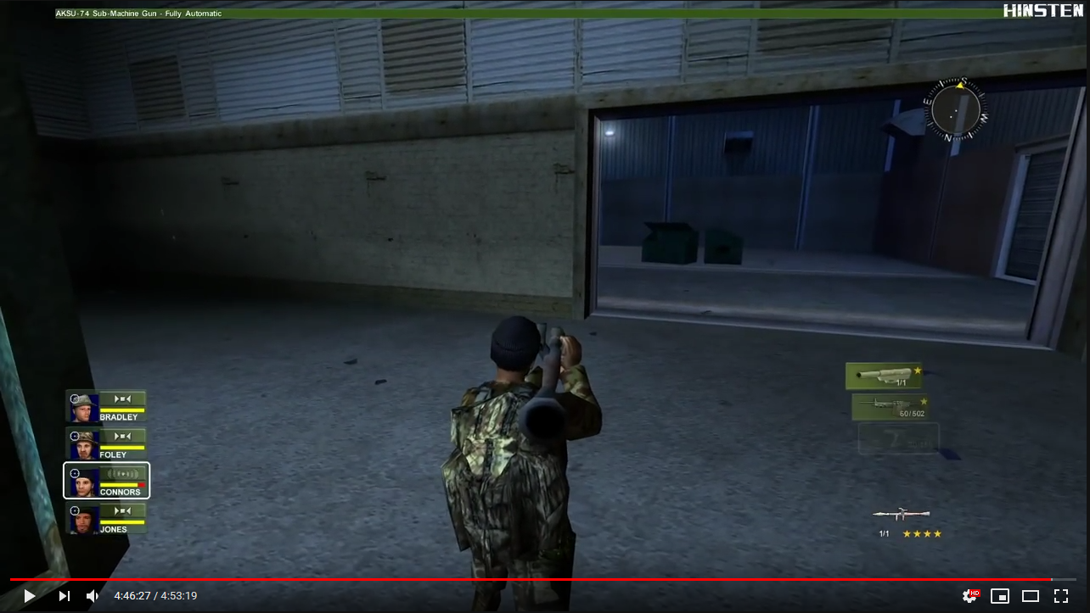

* Left 4 Dead 2
* Transfer some items and heal others
* Instant heal (Desert Storm) or like L4D2?
* Ability to “take break”

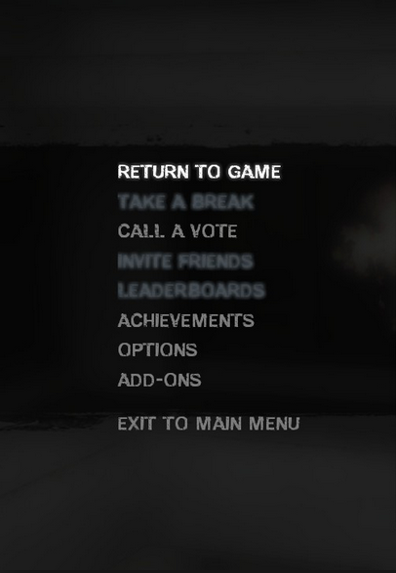

* Call of Duty: Black Ops (Dead Ops arcade) (<https://www.youtube.com/watch?v=t3eQ1Os_vBE>)

